|  |  |
| --- | --- |
| *Pacific Gas and Electric Company* | |
| Release 9.6.1 Installation Guide | |
|  |  |
|  |  |
| Project | ED AM/GIS |
|  |  |
| Prepared by | rprh@pge.com |
| Date | 5/26/2015 |
| Version | 1.0 |
| Version Type | Final |

|  |  |  |  |
| --- | --- | --- | --- |
| Revision History | | | |
| Document # | Date | Author | Summary of Changes |
| 1.0 | 5/26/2015 | Rprh@Pge.Com | Initial Document Creation |

# Introduction

## Purpose

This document is intended to detail the implementation and configuration steps required to implement Release 9.6.1 Installation Guide. This document describes the various configuration aspects required to complete any manual or automatic patch associated with this release. Each section in this document contains the steps required to patch the system in production.

## Terms Used

|  |  |
| --- | --- |
| OOTB | Out of the box. Unmodified from the commercial version. |
| TFS | Team Foundation Server |

## External Documents

Referenced are any external configuration documents or exports. These are documents that contain more detailed information about configuring a system or documents that can be loaded into an application to perform the configuration detailed in this document.

## List Of Fixes

Below is the list of change requests detailing all fixes for the data model for this release:

|  |  |  |
| --- | --- | --- |
| **Item Number** | | **Title** |
| **[21913](http://edappgistfsprd1:8080/tfs/ElectricDistCollection/EDAMGIS/_workitems" \l "_a=edit&id=21913)** | | Master TFS DM9.6.1 |
| [21938](http://edappgistfsprd1:8080/tfs/ElectricDistCollection/EDAMGIS/_workitems#_a=edit&id=21938) | DM 9.6: Alter all Job Annotation classes in the system and un-select the property |
|  |  |
|  |  |
|  |  |
|  |  |
|  |  |
|  |  |
|  |  |
|  |  |
|  |  |
|  |  |
|  |  |

## Summary of Steps to Complete Install

Contents

[1 Introduction 3](#_Toc420423273)

[1.1 Purpose 3](#_Toc420423274)

[1.2 Terms Used 3](#_Toc420423275)

[1.3 External Documents 3](#_Toc420423276)

[1.4 List Of Fixes 4](#_Toc420423277)

[1.5 Summary of Steps to Complete Install 4](#_Toc420423278)

[2 Open a Database Connection in ArcCatalog 6](#_Toc420423279)

[3 21938 DM 9.6.1: Alter all Job Annotation classes in the system and un-select the property 7](#_Toc420423280)

[4 Update Data Model Version Table 10](#_Toc420423281)

[5 Known Issues 11](#_Toc420423282)

# Open a Database Connection in ArcCatalog

1. Open ArcCatalog.
2. Within the Catalog Tree, expand “Database Connections” and open the active connection for this process. This is the connection that is referenced in the change request associated with this document (EDGIS<DB name in the format X#Y> )

# 21938 DM 9.6.1: Alter all Job Annotation classes in the system and un-select the property

1. Expand the Electric Dataset
2. For each annotation class in the below list, complete steps A - H :

EDGIS.CapacitorBank50Anno

EDGIS.CapacitorBankAnno  
EDGIS.DCConductor50Anno  
EDGIS.DCRectifier50Anno  
EDGIS.DCRectifierAnno  
EDGIS.DynProtDevice50Anno  
EDGIS.DynamicProtectiveDeviceAnno  
EDGIS.Fuse50Anno  
EDGIS.FuseAnno  
EDGIS.PriOHConductorAnno  
EDGIS.PriOHConductor50Anno  
EDGIS.PriUGConductor50Anno  
EDGIS.PriUGConductorAnno  
EDGIS.SecOHConductor50Anno  
EDGIS.SecOHConductorAnno  
EDGIS.SecUGConductor50Anno  
EDGIS.SecUGConductorAnno  
EDGIS.StepDown50Anno  
EDGIS.StepDownAnno  
EDGIS.SupportStructure50Anno  -- Anno Class is JobNumber  
EDGIS.SupportStructureAnno  -- Anno Class is JobNumber  
EDGIS.Switch50Anno  
EDGIS.SwitchAnno  
EDGIS.Transformer50Anno  
EDGIS.TransformerAnno  
EDGIS.VoltageRegulator50Anno  
EDGIS.VoltageRegulatorAnno

* 1. Right click <Annotation Feature Class> and choose the properties option

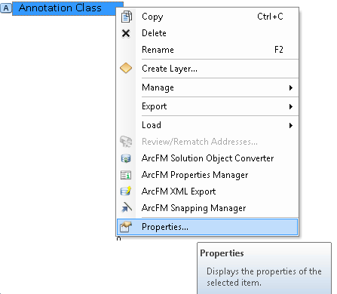

* 1. Select the "Annotation Classes" Tab



* 1. Select the "Job" Annotation Class (may be called JobNumber)
  2. Click the expression button



* 1. Select the Maplex tab



* 1. Uncheck the option for "Remove extra spaces from label".
  2. Make sure that the "Remove extra line breaks from label" is also unchecked (This is by default).

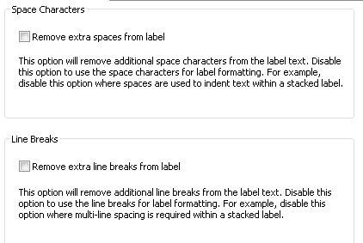

* 1. Click OK to click the Expressions Dialog
  2. Click OK to set these properties and close the Properties Dialog



# Update Data Model Version Table

**Database Configuration:**

1. Open SQL Plus.
2. Log in using the same server and user as was used in section 2.  
     
   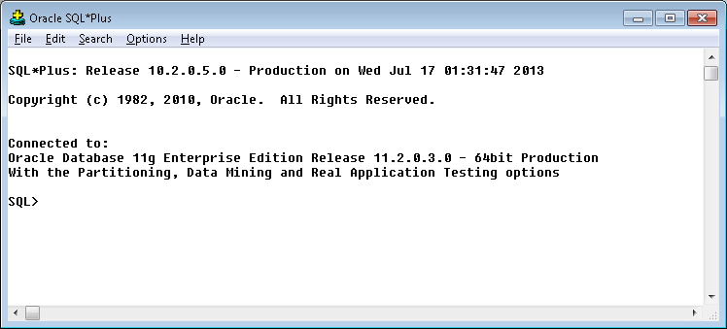
3. Run the SQL below:

update pgedatamodelversion set currentidc='N' where currentidc='Y';

insert into pgedatamodelversion (OBJECTID, CURRENTIDC, DATEAPPLIED, APPLIEDBYPERSONNAME, MODELVERSION) values (**INSERT NEXT VALID ID**,'Y',sysdate,'**<INSERT TEAM MEMBER DONE BY>**','**<INSERT DM VERSION>** GOLD **CR<INSERT CR NUMBER>**');

commit;

# Known Issues

<Please List any other issues encountered here while following the document>